Group 4 – Placental Case
TY is a 27 yo G2P1001 who presents for a follow up ultrasound at 32 weeks due to finding of low-lying placenta in the second trimester. She denies having any bleeding episodes in the pregnancy. She notices intermittent contractions. You obtain the following image:
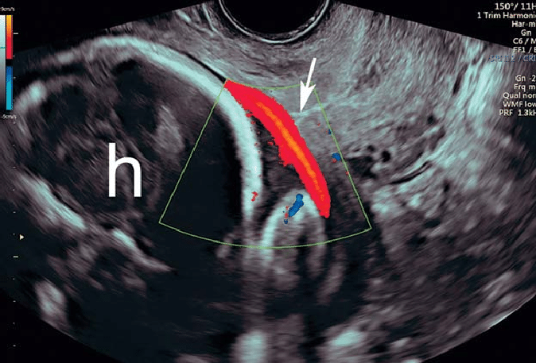

- Describe what you are seeing on ultrasound. How could you further assess this vessel?

- What is the diagnosis?

- Why does this placental abnormality occur? What types of placentas are associated with this finding?

- Are there other risk factors for this finding?

- What are your next steps in management?

- When would you deliver this patient?

