Group 1 – Placental Case
SG is a 32 yo G4P3003 who presents to triage with painless vaginal bleeding at 28 weeks. The patient has not established prenatal care. She has a history of 3 prior cesarean sections. You request an ultrasound and the following image is captured:

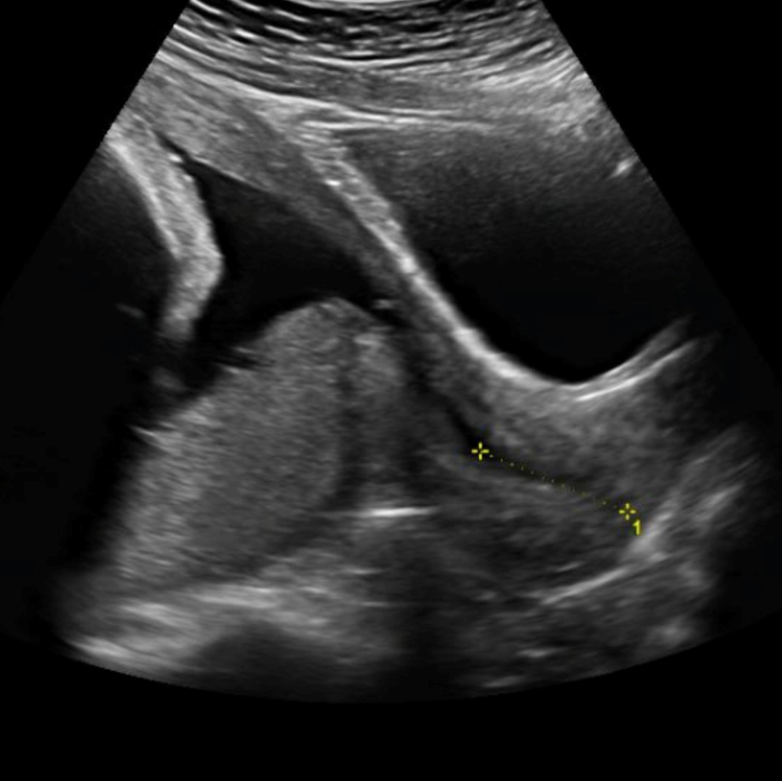

- What is your diagnosis?

- Why does this placental abnormality occur?

- Why does bleeding occur and where does the blood originate from?

- What are the risk factors for this finding?

- What is the risk of placenta accreta spectrum in this patient? It this ruled out given the current location of the placenta?

- What are your next steps in management?

- When would you deliver this patient?

