Teaching to the Texts

Te Linde’s Chapter 7: Surgical Anatomy of the Female Pelvis

CREOG Educational Objectives:
- Describe the anatomy of the abdomen and pelvis
  - Anterior and posterior abdominal wall
  - Pelvic floor
  - Retroperitoneal space
  - Para-aortic space
  - External genitalia
  - Pelvic organs
Practice Questions:
- Chose structure the appropriate structure (A-E) for each of the prompts below:
- During removal of a large lower uterine segment leiomyoma, significant bleeding is encountered. The mass obstructs the lower pelvis and the uterine artery cannot be identified. With ligation of this vessel, the surgeon will decrease the blood flow to the area and improve visibility in the operative field.
- A branch of this major artery is ligated first during a vaginal hysterectomy
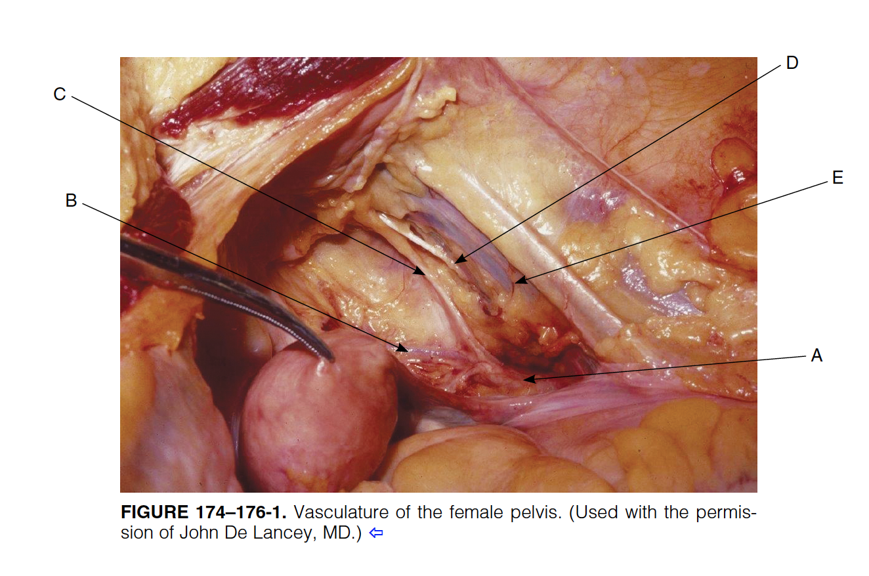
- A 39 year old woman undergoes a laparoscopic hysterectomy with ovarian preservation. During adhesiolysis on the pelvic sidewall near the bifurcation of the common iliac vessels, acute pulseless bleeding is noted. Transection of this vessel in the pelvic sidewall is responsible for the bleeding.

Gyn surg prolog 8th ed, 174-176
2) A G2P2002 is POD3 from a repeat cesarean section. She underwent a trial of labor after cesarean but was diagnosed with arrest of descent and required delivery by repeat cesarean section, which was complicated by extension of the hysterotomy, which required an O’Leary suture. The patient is now complaining of severe back pain. Which of the following is the MOST correct description of the course of the ureter through the pelvis?
- Lateral to the internal iliac branches
- Lateral to the ovarian vessels
- Over the bifurcation of the common iliac artery
- Over the uterine artery
- Under the bifurcation of the common iliac artery
True Learn - Anatomy/ Course of Ureter Through Pelvis
3) A 34 year G3P2002 at 39 weeks is undergoing an elective repeat cesarean section at term. Her pregnancy has been uncomplicated except for some nausea and vomiting in early pregnancy and esophageal reflux in the third trimester. During the operation, you notice an unusual enlargement of the uterine vessels. Thinking back to anatomy class in medical school, you are trying to recall the branches of the anterior and posterior divisions of the internal iliac artery and their importance in pelvic surgery. Which of the following is NOT commonly a branch of the anterior division of the internal iliac artery.?
- Obturator artery
- Superior gluteal artery
- Umbilical artery
- Uterine artery
- Vaginal artery
True Learn: Anatomy: Anterior Division of Internal Iliac Artery
4) A 20 year old G1P0 is admitted to labor and delivery in active labor. She progresses to full dilation and is diagnosed with arrest of descent and undergoes a primary cesarean delivery. Which of the following is the correct order of layers encountered during abdominal wall entry for a Pfannenstiel incision?
- Skin, Camper’s fascia, Scarpa’s fascia, anterior rectus sheath, rectus abdominis muscle, transversalis fascia, peritoneum
- Skin, Camper’s fascia, Scarpa’s fascia, anterior rectus sheath, peritoneum, transversalis fascia
- Skin, Camper’s fascia, Scarpa’s fascia, transversalis fascia, rectus muscle, anterior rectus sheath, peritoneum
- Skin, Scarpa’s fascia, Camper’s fascia, rectus abdominis, anterior rectus sheath, transversalis fascia, peritoneum
- Skin, Scarpa’s fascia, Camper’s fascia, transversalis fascia, rectus muscle, peritoneum
True Learn: Abdominal Wall Anatomy
High-Yield Resources:
- AAGL: Applied Anatomy in the Female Pelvis Video http://surveys.aagl.org/s3/2013surgicalanatomy
- Rahn DD, Phelan JN, Roshanravan SM, White AB, Corton MM. Anterior abdominal wall nerve and vessel anatomy: clinical implications for gynecologic surgery. Am J Obstet Gynecol. 2010 Mar;202(3):234

