Te Linde’s Chapter 27: Tubal Sterilization & Chapter 28: Surgery for Benign Disease of the Ovary

CREOG Learning Objectives:
1. Describe and counsel patients on sterilization including benefits and risks and relative/absolute contraindications for individual patients.
2. Be able to understand and perform abdominal and laparoscopic sterilization.
3. For the following presenting conditions, perform pertinent history and evaluation including diagnostic procedures, consult subspecialists when appropriate, counsel, and manage medically and surgically:
Pelvic masses, including the following etiologies:
a. uterine leiomyomas
b. cystic and solid adnexal/ovarian masses
c. tubo-ovarian abscesses
d. adnexal torsion

Practice Questions:
1. A 28-year-old woman, G3P2, presents to your office to discuss contraception at the time of delivery. She has had one cesarean birth and would like to undergo a repeat elective cesarean birth at 39 weeks. Because she states that she has completed having children, you discuss with her reversible and nonreversible contraceptive options, including immediate tubal ligation at the time of surgery. She had pelvic inflammatory disease as a teenager and has an aunt with ovarian cancer. With regard to permanent sterilization with tubal ligation, you counsel her that she is at highest future risk for
A. ectopic pregnancy
B. ovarian cancer
C. pelvic inflammatory disease
D. posttubal ligation syndrome
E. sterilization regret
Source: REI prolog 8th edition # 125

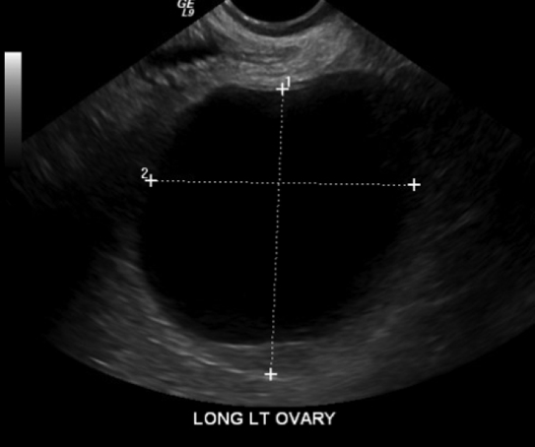
2. A 63-year-old woman, G1P1, comes to your office for a follow-up visit for an asymptomatic left adnexal mass that was diagnosed 6 months ago on bimanual examination. Transvaginal ultrasonography at that time revealed a 7 cm simple adnexal cyst and CA-125 level of 3 IU/mL. She is asymptomatic and reports no abdominal bloating or changes in bowel movements or appetite. Physical examination reveals persistent left adnexal mass that is nontender and mobile. Repeat transvaginal ultrasonography was performed revealing a persistent 7 cm adnexal mass. The best next step in management is
A. computed tomography (CT)
B. repeat transvaginal ultrasound in 6-12 months
C. ultrasound-guided cyst aspiration
D. laparoscopic salpingo-oophorectomy
E. abdominal salpingo-oophorectomy
Source: GYN prolog 8th edition # 73

3. A 42-year-old woman is found to have a pelvic mass when she presents for her well-woman examination. She is asymptomatic and has no pain or abnormal bleeding. Transvaginal ultrasonography reveals a normal uterus with a thin endometrium and a 5-cm cyst with a thin (1-mm) septation. The best next step is:
A. endometrial biopsy
B. ovarian cystectomy
C. magnetic resonance imaging (MRI) of the abdomen
D. repeat ultrasonography in 3-6 months
E. oophorectomy
Source: GYN prolog 8th edition #32

4. A 40-year-old woman, G2P2, returns to your office 3 years after a total abdominal hysterectomy and bilateral salpingo-oophorectomy for stage IV endometriosis with severe adhesive disease. She has been experiencing right sided abdominopelvic pain that is severe and similar to the pain she had before the hysterectomy. Her only medication is an estradiol patch. On examination, she has tenderness in the right lower quadrant and at the right vaginal apex. Ultrasonography suggests a 2 cm x 1.5 cm cyst at the right vaginal apex. The patient requests surgery. The most appropriate next step is
A. laparoscopic removal of the pelvic cyst
B. depot leuprolide treatment for 6 months
C. colonoscopy
D. stop estradiol therapy and obtain FSH level
E. referral to a chronic pain clinic
Source: GYN prolog 7th edition, #17

5. A 24-year-old nulligravid woman presents to the emergency department with severe right lower quadrant pain with associated nausea and vomiting for the past 24 hours. Ultrasonography reveals a right-sided 6-cm unilocular ovarian cyst. The uterus and contralateral ovary appear normal. She undergoes laparoscopy, and intraoperatively the ovary appears ischemic and necrotic with poor blood flow and blue-black areas, which do not improve after detorsion. The best next step is to
A. conclude the procedure
B. perform oophorectomy
C. perform ovarian cystectomy
D. perform salpingo-oophorectomy
Source: GYN prolog 8th edition, #8

High-Yield Resources:
1. Practice Bulletin # 174: Evaluation and Management of Adnexal Masses
2. Practice Bulletin #208: Benefits and Risks of Sterilization
3. Pearls of Exxcellence: Laparoscopic Sterilization
https://www.exxcellence.org/list-of-pearls/laparoscopic-sterilization/?categoryName=&searchTerms=&featured=False&bookmarked=False&sortColumn=date&sortDirection=Descending
4. Pearls of Exxcellence: Management of Adnexal Masses in Pregnancy
https://www.exxcellence.org/list-of-pearls/management-of-adnexal-masses-in-pregnancy/?categoryName=&searchTerms=&featured=False&bookmarked=False&sortColumn=date&sortDirection=Descending
5. Pearls of Exxcellence: Management of Adnexal Masses in an Older Woman
https://www.exxcellence.org/list-of-pearls/evaluation-of-the-adnexal-mass-in-an-older-woman/?categoryName=&searchTerms=&featured=False&bookmarked=False&sortColumn=date&sortDirection=Descending

Answers:
1. e 2. b 3. d 4. d 5. c

