Te Linde’s Chapter 25: Surgery for Anomalies of the Mullerian Ducts

** The learning objectives for this chapter are the same as the learning objectives from last week (Williams OB chapter 3), but the practice questions are different **

CREOG Learning Objectives:
1) Describe the embryology of the pelvis and pelvic organs:
a. Describe normal development
b. Describe abnormal development, including ambiguous genitalia, Mullerian agenesis, and vaginal/uterine septum
2) For the Mullerian agenesis, describe the appropriate screening, diagnosis, pertinent history, focused physical examination, diagnostic testing and treatment, and indications for referral.
3) Understand and be able to perform hysteroscopic resection of a uterine septum

Practice Questions:
1) An 18-year old woman presents with a known diagnosis of Mullerian agenesis. She is going to college in 6 months and would like to have a functional vagina. She reports no pelvic or abdominal pain. She has never attempted sexual intercourse. On examination, she has normal external genitalia and a vaginal dimple. The preferred approach to creation of a neovagina for this patient is

A. dilation vaginoplasty
B. intestinal vaginoplasty
C. peritoneal vaginoplasty
D. traction vaginoplasty
E. vaginoplasty with split-thickness skin graft
Source: PROLOG REI 8th edition #26

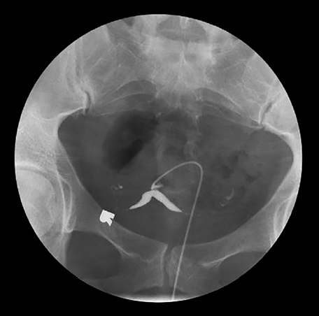
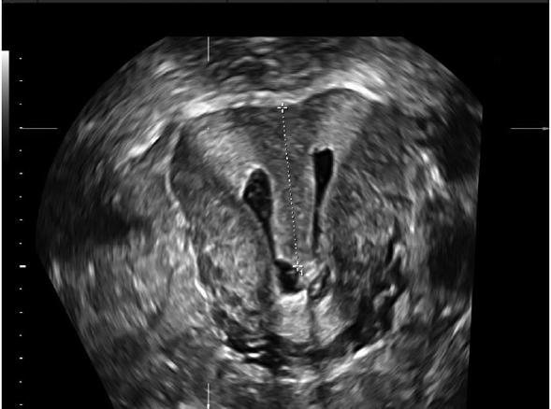
2) A 32- year old woman, gravida 4, para 0, with three first-trimester spontaneous abortions and one second-trimester spontaneous abortion presents to your office. The patient currently is not pregnant and wants to determine the cause of recurrent pregnancy loss and prevent another miscarriage. Laboratory workups for recurrent pregnancy loss, including TSH, hemoglobin A1c, antiphospholipid antibody panel, and parental karyotypes were normal. HSG and 3D saline ultrasonography are demonstrated below. The best next step in management is:

A. cervical cerclage in next pregnancy
B. computed tomography of kidneys and pelvis
C. magnetic resonance imaging (MRI) of the kidneys and pelvis
D. operative hysteroscopy
E. Strassman procedure
Source: PROLOG REI 8th edition # 37

3) A 37-year old nulligravid patient undergoing fertility evaluation has an HSG demonstrating a uterine septum. You elect to perform an operative hysteroscopy for resection of the structure. Which of the following does not represent an endpoint to the procedure?

A. a level line between the tubal ostia
B. bleeding
C. increased tissue vascularity
D. involution of the uterine fundus
E. serosal transillumination of the hysteroscopy at the uterine fundus
Source: TrueLearn

4) A 28-year old woman presents with a history of recurrent pregnancy loss. During the workup, she is found to have an anatomical uterine anomaly. She is told, however, that this anomaly is unlikely the etiology of her condition, and additional testing is recommended. Which of the following sonographic findings is consistent with the uterine anomaly with the best
reproductive prognosis?

A. Two separate divergent uterine horns with a deep fundal cleft between the 2 hemiuteri and a widened angle between 2 endometrial cavities
B. narrow angle between 2 endometrial cavities, $≤$75 deg, and a fundal shape with a notch $≤$1 cm.
C. Hypoechoic lines disrupting the echogenic endometrium
D. Well-defined elliptical-shaped uterus with deviation
E. Wide-angle between 2 endometrial cavities, $≥105$ deg, and a fundal shape with notch $≥$ 1 cm
Source: TrueLearn

High-Yield Resources:
1) Committee Opinion #728: Mullerian agenesis: Diagnosis, Management, and Treatment
2) Committee Opinion # 729: Management of Acute Obstructive Uterovaginal anomalies
3) Committee Opinion # 780: Diagnosis and Management of Hymenal Variants
4) CREOGS over coffee Episode 80: Mullerian Anomalies and Variants https://creogsovercoffee.com/notes/2020/3/29/mullerian-anomalies

Answers:
1) a 2) d 3) d 4) a

