Te Linde’s Chapter 10: Water, Electrolyte, and Acid- Base Metabolism

CREOG Educational objective:

- Independently understand and perform an arterial blood gas assessment.
- Understand risk factors, etiologies, signs and symptoms, evaluation, initial management, and indications for referral for fluid and electrolyte imbalance, including abnormal urinary output.

Practice Questions:

1) A 26 year old woman at 17 weeks’ gestation presents to labor and delivery complaining of severe nausea and vomiting with diarrhea for 4 days. The patient states that she recently traveled overseas and arrived home the day before. She states that she was ill during the trip as well. Upon examining the patient, you note that her mucous membranes are dry, and her eyes are sunken. A decision is make to admit the patient and start IV fluids to treat dehydration. Labs are drawn. Which of the following parameters does NOT increase with dehydration?
a. ADH (antidiuretic hormone)
b. Serum osmolality
c. Serum potassium
d. Serum sodium
e. urine osmolality
Source: TrueLearn

2) For each clinical scenario, choose the likely hemodynamic profile (A-E).

1. Hypovolemic shock
2. Septic shock
3. Cardiogenic shock

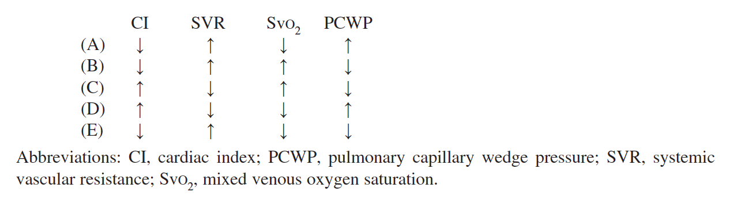
Source: Gyn onc prolog #148-150

3) A 48 year old hypertensive woman is on postoperative day 2 after a total hysterectomy for a myomatous uterus. She had intraoperative hypotension corrected with infusion of salvaged red blood cells, crystalloid, and vasopressors. Cystoscopy at the end of the surgery was normal. Her vital signs are blood pressure 120/70, pulse 90, temp 36.5 C, and RR 18. Her urine output was low during surgery but picked up to 1 mL/kg/hr overnight. Her hemoglobin is 9.8 g/dL and creatinine is 2.3 mg/dL versus 1.0 mg/dL at her preoperative visit. The best net stei in management is:
A. maintenance intravenous fluid
B. hetastarch
C. low dose dopamine
D. loop diuretics
E. theophylline
Source: Gyn onc prology #139

4) A 52 year old woman, para 2, reports to the emergency room with fatigue, weakness, and vaginal bleeding. She has not had a pelvic exam in 10 years and states that the bleeding is worse with douching and intercourse. She has a history of hypertension and, based on the advice of a family member, increased her ACE inhibitor because of elevated BP readings. Her pelvic exam reveals a friable 6 cm cervical mass with bilateral parametrial nodularity. Bedside bladder ultrasonography shows minimal urine in the bladder. Renal ultrasonography demonstrates the findings below and EKG reveals the pattern below:
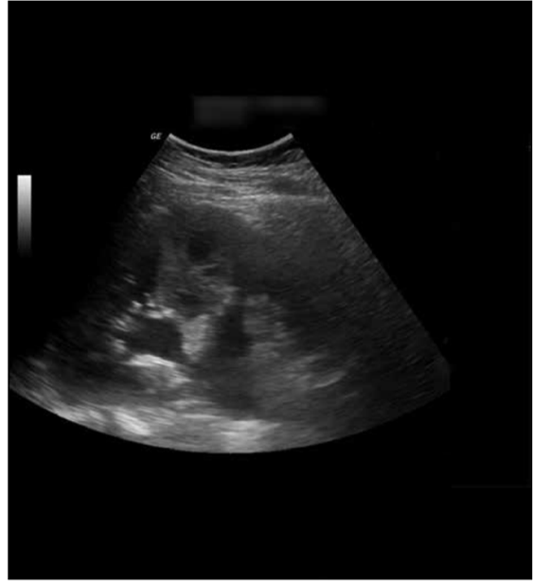
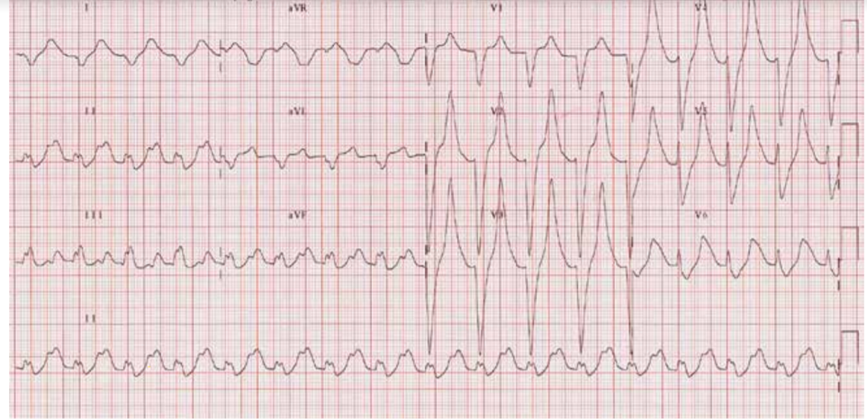

After starting intravenous fluids, the first step in management should be infusion of
A. potassium
B. calcium
C. loop diuretic
D. insulin
E. amiodarone
Source; Gyn onc prolog #32

High-Yield Resources:
1) UpToDate: Arterial blood gases
2) UptoDate: Simple and mixed acid base disorders
3) Quick electrolyte repletion guide: http://uicchicago.sharpschool.com/UserFiles/Servers/Server_442934/File/imr_housestaff/version1/Survival_Website_files/Page1211.htm

True Learn Answers
1) c

