Group 3 – Placental Case
MH is a 37 yo G1 at 33w2d who presents with vaginal bleeding and lower abdominal discomfort. Her pregnancy has been complicated by chronic hypertension managed with labetalol. Your exam shows 100 cc of dark blood clot in the vault. You order an ultrasound which shows the following:
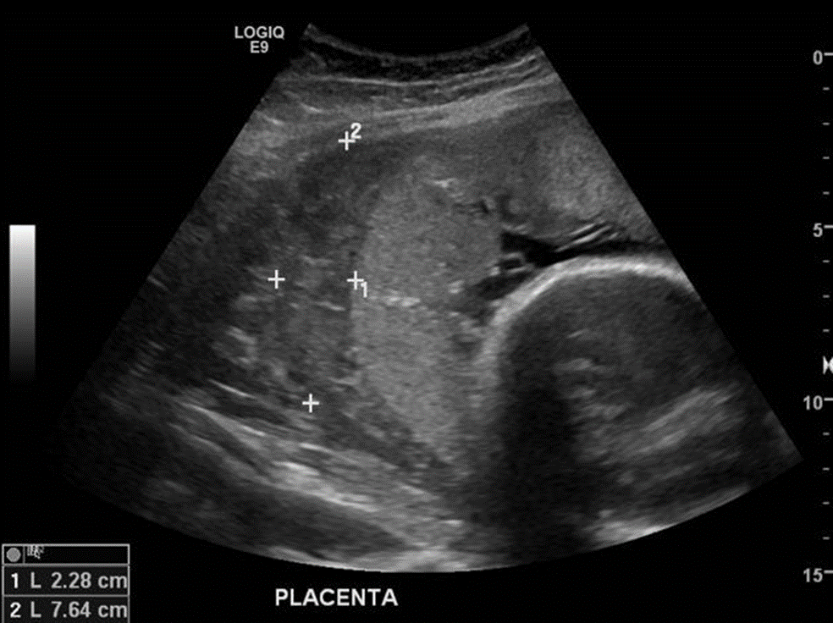

- Describe what you are seeing on ultrasound.

- What is your leading diagnosis?

- Why does this placental abnormality occur?

- What are the risk factors for this finding?

- What are your next steps in management?

- When would you deliver this patient?

- What is a Couvelaire uterus and how does this happen?

