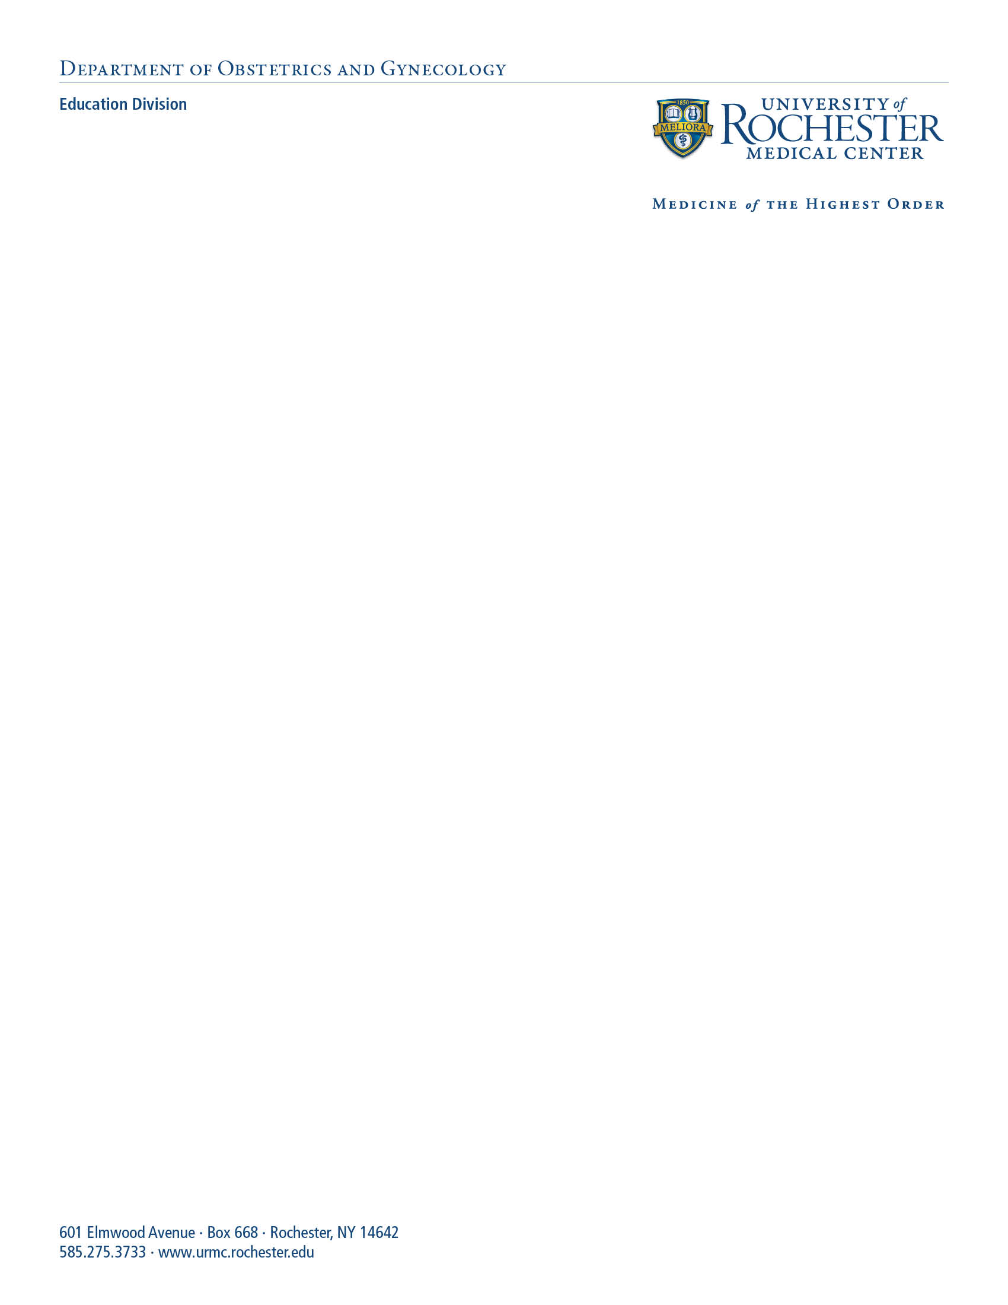

Hi everyone,

As you may have heard in our FT/PT meeting last week, we are transitioning the residency curriculum this year in several ways. First, two of our rising R3s (Kaylee Underkofler and Ally Morell) have designed an outline of core topics for the year based on two key textbooks in our field. This outline runs for 2 years so we will only be covering 50% of the topics this year. The idea is that the textbook chapters will serve as background reading for the residents, and the protected time on Thursday mornings can be used for a variety of teaching formats. Kaylee and Ally will also be creating a brief handout to go with each book chapter that will include additional relevant resources (like Practice Bulletins or other ACOG publications) as well as a few related practice questions.

We would love to have your participation and involvement in residency didactics this year! We are asking that each core faculty member sign up for 2 teaching spots during the year. Simulation events and CREOG reviews are included. Dr. Burhans leads the simulation program, and she has already outlined potential simulation activities for each SIM day. You can find these details of these on our website. Ky, Kristen and I are excited and happy to work with each of you to design the teaching format that you prefer. Some people may want to give a traditional “chalk talk” while others might prefer to use a pre-recorded lecture (either of themselves or a national expert: see [www.efaobgyn.com](http://www.efaobgyn.com/)) and then do practice questions with the residents in person. You may decide to bring real life cases from your practice and work through these together with the residents. Attached is a list of potential formats for residency didactics. We will be meeting via Zoom in the beginning (until larger gatherings are allowed). We are working on ways to spend SIM time in person but divided into small groups.

Please let me know if you have any questions about the plans for the coming year. We really appreciate all that you do to provide excellent training opportunities for our residents. We are trying to make this process more organized and streamlined. We will also have a better system for evaluating the teaching that you provide. We welcome any feedback that you have.

The master schedule of Thursday morning didactics is attached. To sign up for teaching, please check out the website listed below. This video provides detailed instructions: <https://vimeo.com/427939268>. Please *do not* use Internet Explorer when you are accessing this site. If you have not already done so, you will need to create an email login and password. If you have any issues with the website, please reach out to [Kyan_Lynch@urmc.rochester.edu](mailto:Kyan_Lynch@urmc.rochester.edu) for support.

Sign Up to Teach Here: <https://www.everbettertogether.com/residency>

We are looking forward to a great year!  
Courtney