Hello all,
This email is to inform you that the Relias platform, previously known as GNOSIS, has completed its system upgrade. Relias is the learning management interface that has integrated and enhanced the former GNOSIS courses that URMC and MCIC have become so accustomed to using. The platform URL address and interface have changed so I wanted to provide you with a step by step tutorial on how to access your required education.
Just like GNOSIS, Relias has a personalized learning method with script concordance theory that will develop individualized learning based upon an initial pre-course assessment.
How to access Relias Learning:
To log into Relias, use the URL: https://login.reliaslearning.com
You will be directed to the Relias homepage (see below). Each staff member has been auto enrolled into the Relias learning platform:
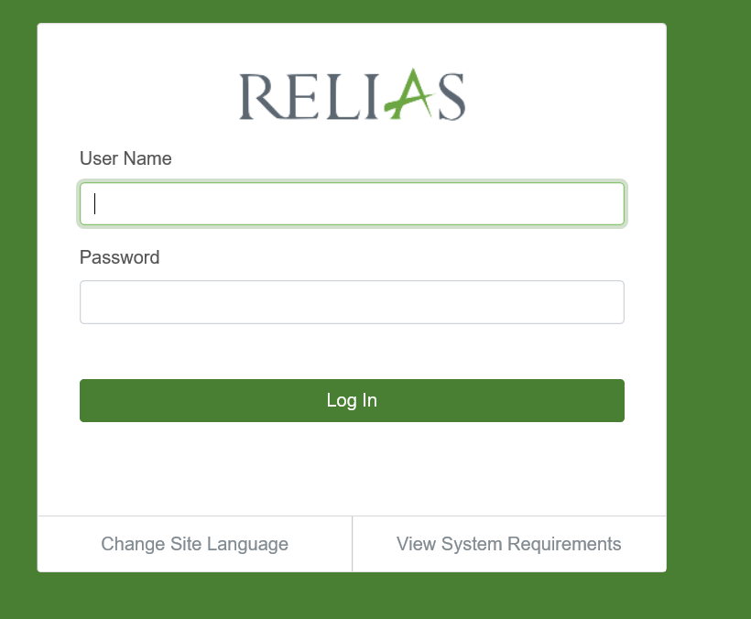
Username:
Your username is your previous GNOSIS username, for most it is you URMC email address.
Note: For new on boarded staff members who DID NOT create their own GNOSIS account, your username will be your URMC email address.
Password:
Each account is set up with a generic password. Type in Welcome1 (case sensitive) to log into the platform. You will be immediately directed to change your password. 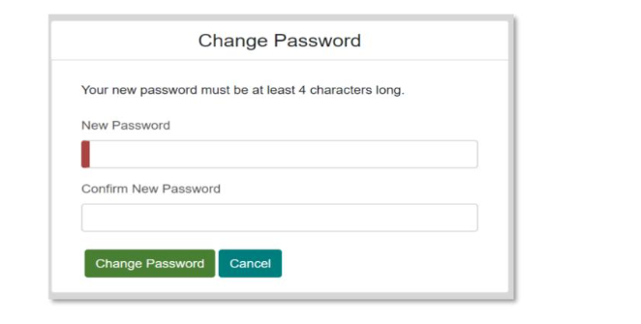
Upon log-in, you will be asked to complete 3 security questions that will allow you to retrieve forgotten passwords if needed.
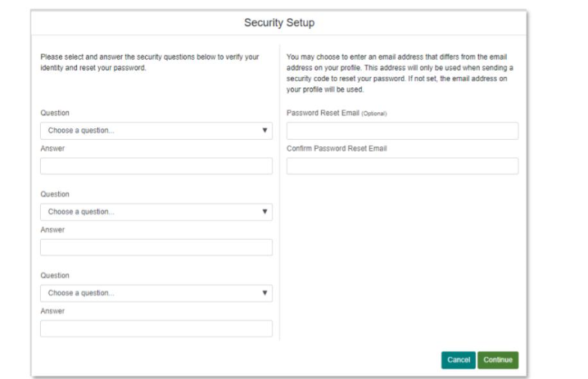
Once you have completed your log-in, you will be directed to your individualized learning dashboard.
Learning Dashboard:
You will be directed to your individualized learning dashboard that lists current training. Some of the names of the original GNOSIS course have changed slightly due to requirements for credentialing of the courses.
As we know, for 2020, all inpatient Obstetricians, Residents, Fellows, Certified Nurse Midwives, NP’s and Registered Nurses must complete the Fetal Heart Rate and Uterine Contraction Monitoring Course (previously titled, Fetal Monitoring and Assessment Course) by Tuesday December 1, 2020.
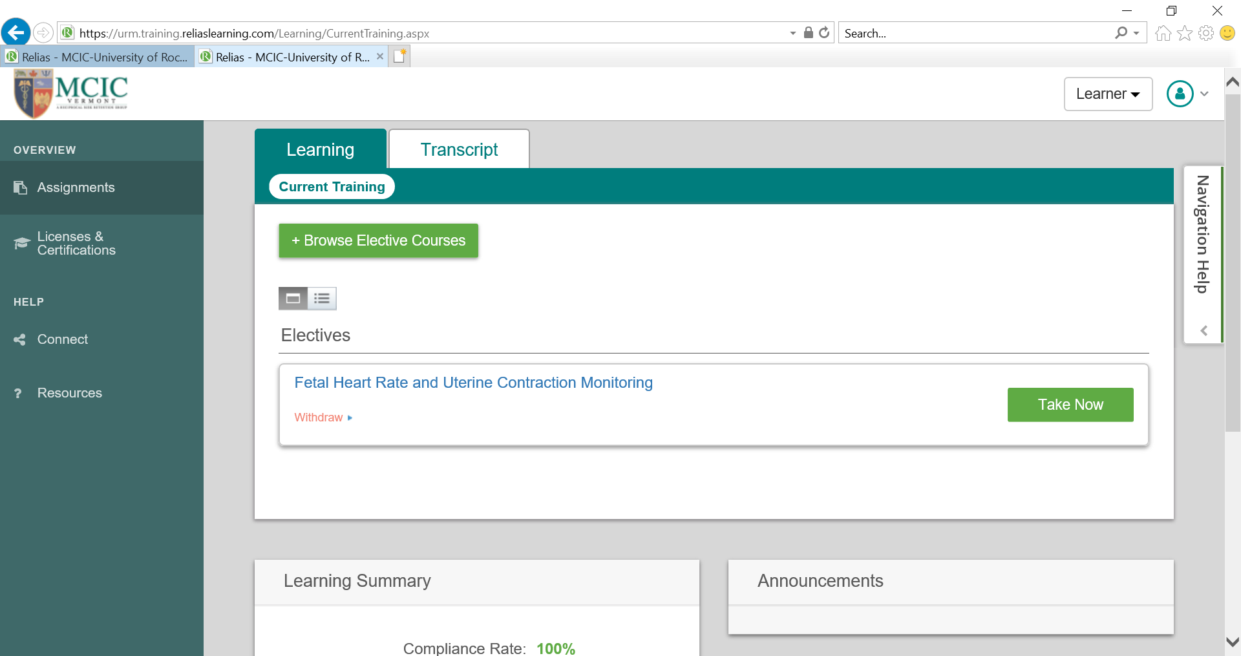
GREAT NEWS!
Each year, you will be AUTO ENROLLED into the MCIC required course for the corresponding year. The course will have a due date that will prompt the system to provide you with regular reminders to complete your annual training! This should reduce the confusion as to what course is due for both MCIC and Provider Malpractice Reduction for that particular calendar year!
When you have dedicated time to take the Fetal Heart Rate and Uterine Contraction Monitoring Course, click “Take Now” and it will direct you to the course content.
Please Note: For the staff members who already successfully completed the required Fetal Monitoring Course prior to June 30, 2020, have met their annual requirement and were not enrolled into the Fetal Heart Rate and Uterine Contraction Monitoring Course.
If you were not auto enrolled into the course and you did NOT complete your required training, please email me at Stephanie_Havens@urmc.rochester.edu
New on-boarded staff members (under 12-18 months of hire):
Each new hire to the Department of OB/GYN, must complete the Fetal Heart Rate and Uterine Contraction Monitoring Course by 12 months of hire in preparation for the PQF certification exam. The due date for your course may be slightly different than the rest of the staff or at times you may have more than one course assigned in a calendar year.
If you would like to utilize the Relias learning course multiple times for study purposes, email me at Stephanie_Havens@urmc.rochester.edu for assistance.
Additional Education and Clinical Pearls:
If you are interested in obtaining additional CNE/CME’s or to enhance your learning on a particular topic, you can access these courses by clicking, “Browse Elective Courses” and you can review the catalog.
Fetal Heart Rate and Uterine Contraction Monitoring Course Content:
The previous Fetal Monitoring and Assessment Course content was focused on ensuring that L&D units across the country were aware of, implementing, and utilizing standard language and the three-tier classification system as developed by the National Institute of Child Health and Human Development (NICHD).

The updated Fetal Heart Rate and Uterine Contraction Monitoring Course focuses on what was learned in the NICHD language, interpretation and classification system to active clinical management of Cat II and Cat III tracings. There is additional precision on physiologic foundations of fetal heart rate monitoring and unit based practices to include Team STEPPS methodologies for communication, safety, and teamwork.

The course layout is very similar to the previous GNOSIS platform.
- You will first complete a 136 question assessment course.
- Once you complete the pre-course assessment, an individualized learning path will be created based on your areas of weakness.
  - Similar to the GNOSIS platform, the areas of weakness will be color designated as “red” (high educational need), “yellow” (more reinforced knowledge needed) and “green” (have a strong understanding of that area of content).
  - You must complete the “red” and “yellow” areas to complete the learning path. Completing the “green” modules are optional. The course will direct you complete the required modules.
- When you have completed the pre-assessment and the individualized learning path, you will be directed to complete a 10 question post-test.
  - To pass the post-test, you must attain a score of 70% or better for continuing education credit.
- Once you complete the post-test, you will be directed to complete a post-course evaluation.
- When you are finished, your transcript will congratulate you that you have finished the course!
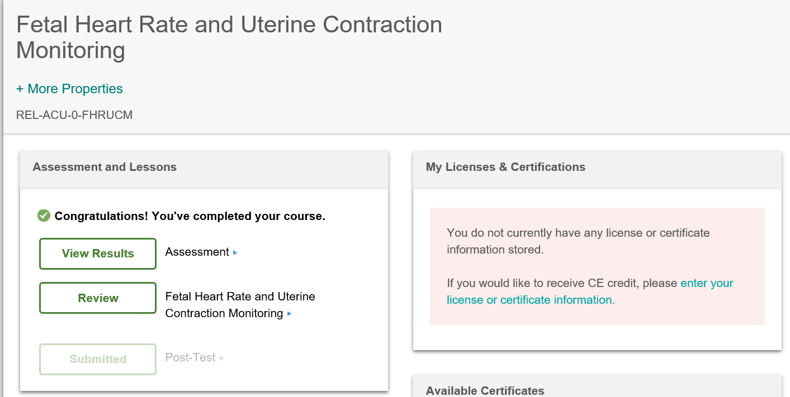
How to print/email a certificate?
Click on the that link “available certificates” in the left hand navigator and you will be directed to a catalog to either print or email certificates.
I would recommend printing a certificate for your own personal records.
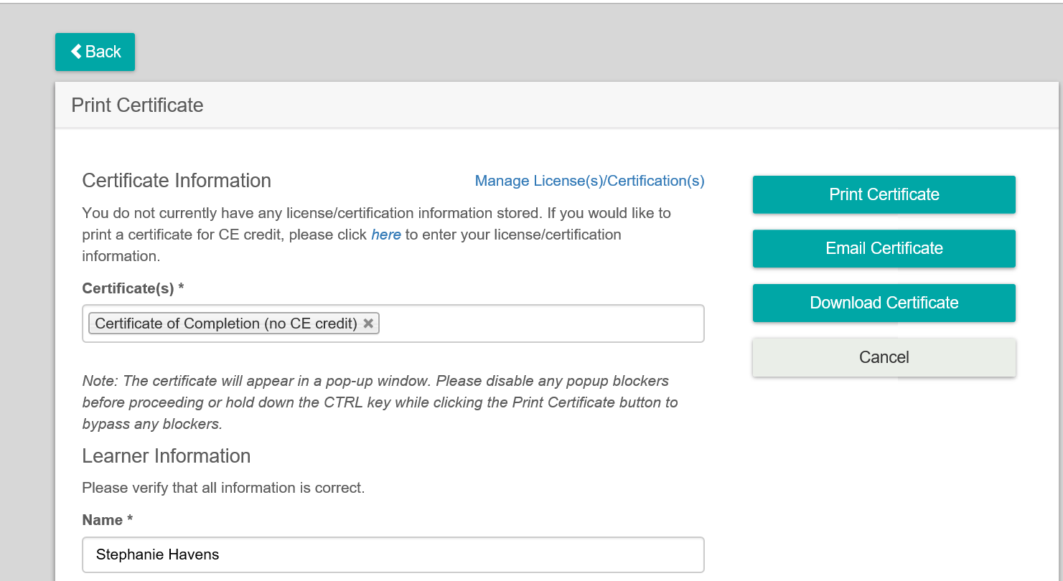
What if I do poorly?
Starting in 2020, as a way to evaluate all certified practicing provider’s (nurses and providers) ongoing competency in electronic fetal monitoring, the MCIC patient safety leadership committee created an initiative to evaluate those individuals that score below the 25th percentile in basic knowledge and judgement.

In the instance that you score below the 25th percentile in knowledge and judgement, I will send you an individualized letter summarizing your areas of weakness and we will meet together to collaboratively create a timeline for remediation and reassessment of the Fetal Heart Rate and Uterine Contraction Monitoring Course.

If you have any additional questions, or need assistance with accessing your Relias Learning course, please feel free to reach to me at Stephanie_Havens@urmc.rochester.edu

