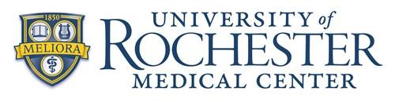
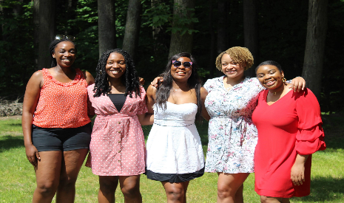
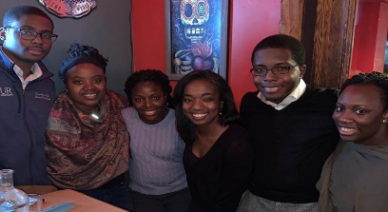
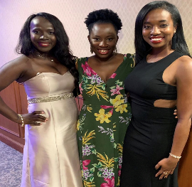
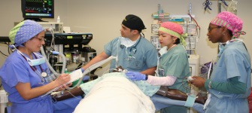
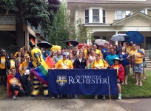
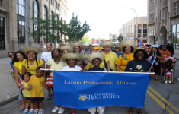
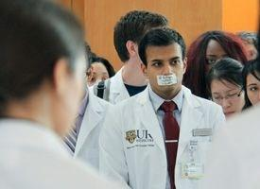
Promoting Excellence through Diversity

The University of Rochester is a community that welcomes, encourages, and supports individuals who desire to contribute to and benefit from the institution’s missions of teaching, research, patient care, and community service. The University of Rochester welcomes diversity of all kinds – gender, religion, race, ethnicity, culture, socio-economic background.

The medical center and university are committed to fostering an inclusive and diverse learning environment for our students, residents, and fellows through a variety of means, including:
- Dedicated support through the Office of Equity and Inclusion from the undergraduate to graduate level,
- Mentoring & networking opportunities for trainees, including through the Association of Minority Residents & Fellows,
- Affinity & support groups (Latino Professional Alliance, Minority Male Leadership Association, Pride Alliance at UR, Sankofa/African American Network, Veterans Alliance, Women’s Leadership Alliance, Young Leaders at UR),
- Active recruitment of diverse faculty and university personnel,
- Mentoring & networking programs for diverse faculty to enhance both recruitment and retention,
- A variety of cultural & educational programs including an annual diversity conference and monthly diversity seminar series.

We are proud of the welcoming and inclusive community we have, and we continue to live by our motto “Meliora”- Ever better!

UR Affinity Groups
- Four Directions (Native American)
- Latino Professional Alliance at UR
- Minority Male Leadership Association
- Pride Alliance at UR
- Sankofa (formerly African American Network)
- South Asian Professional Networking Association
- Veterans Alliance
- Women’s Leadership Alliance
- Young Leaders at UR
URMC Networking Resources
  - Association of Minority Residents & Fellows
  - Women in Science & Medicine Faculty Advisory Committee
  - LGBT Faculty Advisory Committee
  - Minority Faculty Advisory Committee
  - Medical Student Affinity & Interest Groups
    - American Medical Women’s Association, Asian Pacific American Medical Students Association, Islamic Medical Association of North America, Physicians for Human Rights, SPECTRUM, Student National Medical Association
  - Graduate Student Affinity Groups
    - Graduate Women in Science, Graduate Students of Color
  - Black Physicians Network of Greater Rochester
Educational & Cultural Programs
- Tana Grady-Weliky, MD Annual Lecture on Women and Minorities in Medicine
- Third Thursdays Performing Arts & Culture
- Celebrating Diversity & Inclusion at URMC (annual poster event)
- Diversity Seminar Series (monthly)
- Biennial Conference on Healthcare Disparities
- UR Annual Diversity Conference

